Ingress:

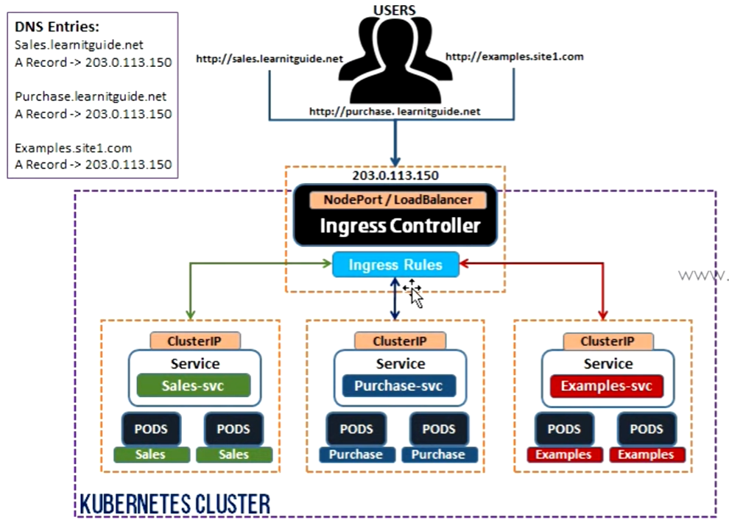

Ingress routes the traffic with set of rules.

Ingress is a single resource that helps us load balancing, name based virtual hosting and SSL terminations etc.

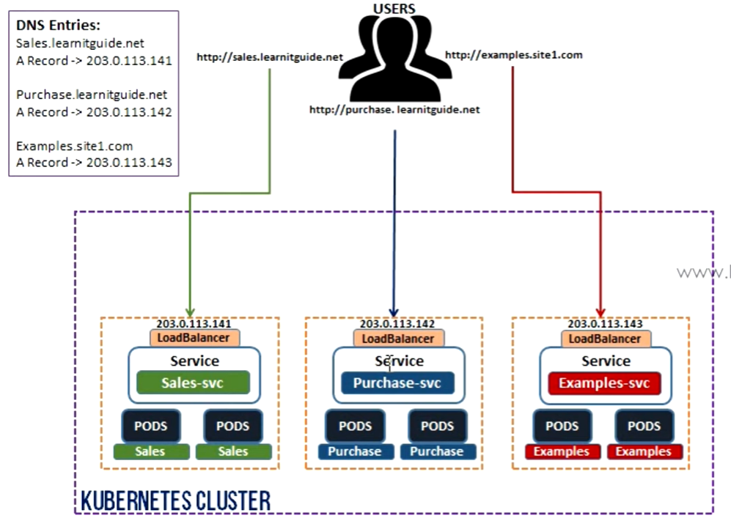

As above, we have to user load balancer or nodeport service type in services to expose the pods.

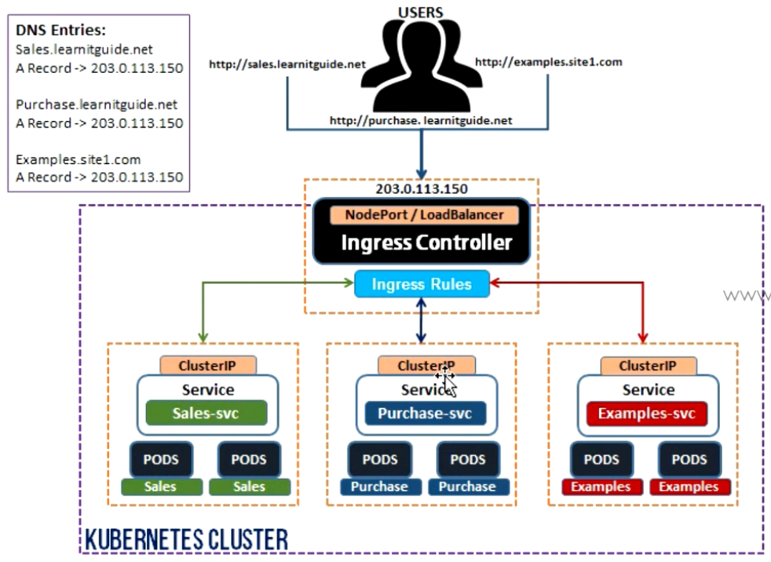

But in ingress, we no need to create different entry points to each service as per the previous image. We can have single entry point for all our applications.

Ingress manifest:

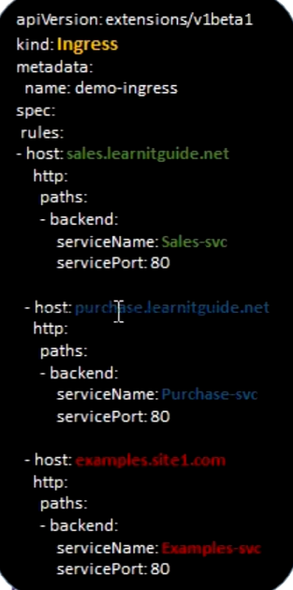

As above, the redirection happens to the particular service based on the path.